**Bug Report:**

**Bug 1:** Game does not pay out at correct level. When player wins on 1 match, balance does not increase.

Initial bet value is reduced from the player and on the very first go.

**Bug 2:** Player cannot reach betting limit: Limit set to 0, but game ends with player still with 5 (dollars) remaining.

**Bug 3:** Odds in the game do not appear to be correct. Crown and Anchor games have an approximate 8% bias to the house. So the win : (win+lose) ratio should approximately equal 0.42. This does not appear to be the case.

**The other bugs that haven’t been reported are:**

1. If the player of the game happens to win on all the dice moves, he is only awarded once i.e. the player is only winning once at most.

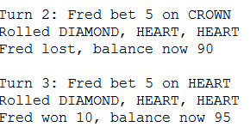

1. The code has a condition to quit the game but that never gets executed. The player has to play all the turns and is never allowed to quit the game.

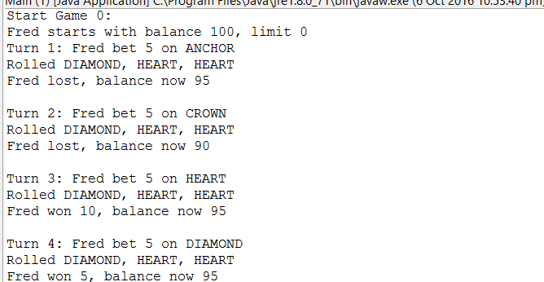

1. Initial Player Name and balance are always the same.

